Data Praticum II

Correlation between No_HS and No_Job is substantial at 0.489. Correlation between Chg_Job and Chg_Biz is not great at 0.375, however it is the biggest correlation that involves either of those two factors. Expectedly, Med_Inc and Poverty have the greatest correlation at -0.64. This is followed by Poverty and No_HS which has a correlation of -0.63.

Below are the correlations between DCI rank and the 7 factors plus population.

#Correlations between DCI and the rest  
res_DCI <- cor(DCI_2[-9], DCI_2$DCI_Rank)  
res_DCI

## [,1]  
## Population -0.1230537  
## No_Diploma 0.6604072  
## Vacancy 0.5667272  
## No_Job 0.6697394  
**## Poverty 0.7466504  
## Med_Inc -0.7435667**  
## Chg_Job -0.2279098  
## Chg_Biz -0.3546094

library(readxl)

## Warning: package 'readxl' was built under R version 3.4.3

#Importing the data set  
DCI <- read.csv("C:/Users/Daniel Tagle/Documents/Data Practicum 2/DCI Components v3.csv")  
DCI_3 <- read.csv("C:/Users/Daniel Tagle/Documents/Data Practicum 2/DCI Components v3.csv")

#Removing superflous columns  
DCI_3$Zip_Code <- NULL  
DCI_3$City <- NULL  
DCI_3$State <- NULL  
DCI_3$No_Diploma_Rank <- NULL  
DCI_3$Vacancy_Rank <- NULL  
DCI_3$No_Job_Rank <- NULL  
DCI_3$Poverty_Rank <- NULL  
DCI_3$Med_Inc_Rank <- NULL  
DCI_3$Chg_Job_Rank <- NULL  
DCI_3$Chg_Biz_Rank <- NULL  
DCI_3$Avg_Rank <- NULL  
DCI_3$DCI <- NULL  
DCI_3$DCI.246.45 <- NULL  
DCI_3$DCI_Sacled_Round <- NULL  
DCI_3$DCI_Sacled_Truncated <- NULL  
DCI_3$Normalized.DCI <- NULL  
DCI_3$DCI_Normalized <- NULL  
  
DCI_2 <- DCI_3  
DCI_2$DCI_Rank <- DCI$DCI

#Creating the correlation matrix  
res <- cor(DCI_3)  
round(res, 2)

## Population No_Diploma Vacancy No_Job Poverty Med_Inc Chg_Job  
## Population 1.00 0.05 -0.21 -0.09 0.06 0.13 -0.01  
## No_Diploma 0.05 1.00 0.31 0.49 0.63 -0.53 -0.01  
## Vacancy -0.21 0.31 1.00 0.36 0.40 -0.39 -0.01  
## No_Job -0.09 0.49 0.36 1.00 0.57 -0.46 -0.02  
## Poverty 0.06 0.63 0.40 0.57 1.00 -0.64 -0.04  
## Med_Inc 0.13 -0.53 -0.39 -0.46 -0.64 1.00 0.07  
## Chg_Job -0.01 -0.01 -0.01 -0.02 -0.04 0.07 1.00  
## Chg_Biz 0.10 -0.04 -0.08 -0.07 -0.08 0.15 0.38  
## Chg_Biz  
## Population 0.10  
## No_Diploma -0.04  
## Vacancy -0.08  
## No_Job -0.07  
## Poverty -0.08  
## Med_Inc 0.15  
## Chg_Job 0.38  
## Chg_Biz 1.00

#Calling the Hmisc package for correlation p-values  
library(Hmisc)

## Warning: package 'Hmisc' was built under R version 3.4.4

## Loading required package: lattice

## Loading required package: survival

## Loading required package: Formula

## Warning: package 'Formula' was built under R version 3.4.1

## Loading required package: ggplot2

## Warning: package 'ggplot2' was built under R version 3.4.1

##   
## Attaching package: 'Hmisc'

## The following objects are masked from 'package:base':  
##   
## format.pval, units

#Creating object with corr and p-value  
res2 <- rcorr(as.matrix(DCI_3))  
res2

## Population No_Diploma Vacancy No_Job Poverty Med_Inc Chg_Job  
## Population 1.00 0.05 -0.21 -0.09 0.06 0.13 -0.01  
## No_Diploma 0.05 1.00 0.31 0.49 0.63 -0.53 -0.01  
## Vacancy -0.21 0.31 1.00 0.36 0.40 -0.39 -0.01  
## No_Job -0.09 0.49 0.36 1.00 0.57 -0.46 -0.02  
## Poverty 0.06 0.63 0.40 0.57 1.00 -0.64 -0.04  
## Med_Inc 0.13 -0.53 -0.39 -0.46 -0.64 1.00 0.07  
## Chg_Job -0.01 -0.01 -0.01 -0.02 -0.04 0.07 1.00  
## Chg_Biz 0.10 -0.04 -0.08 -0.07 -0.08 0.15 0.38  
## Chg_Biz  
## Population 0.10  
## No_Diploma -0.04  
## Vacancy -0.08  
## No_Job -0.07  
## Poverty -0.08  
## Med_Inc 0.15  
## Chg_Job 0.38  
## Chg_Biz 1.00  
##   
## n= 24645   
##   
##   
## P  
## Population No_Diploma Vacancy No_Job Poverty Med_Inc Chg_Job  
## Population 0.0000 0.0000 0.0000 0.0000 0.0000 0.0873   
## No_Diploma 0.0000 0.0000 0.0000 0.0000 0.0000 0.0219   
## Vacancy 0.0000 0.0000 0.0000 0.0000 0.0000 0.0262   
## No_Job 0.0000 0.0000 0.0000 0.0000 0.0000 0.0020   
## Poverty 0.0000 0.0000 0.0000 0.0000 0.0000 0.0000   
## Med_Inc 0.0000 0.0000 0.0000 0.0000 0.0000 0.0000   
## Chg_Job 0.0873 0.0219 0.0262 0.0020 0.0000 0.0000   
## Chg_Biz 0.0000 0.0000 0.0000 0.0000 0.0000 0.0000 0.0000   
## Chg_Biz  
## Population 0.0000   
## No_Diploma 0.0000   
## Vacancy 0.0000   
## No_Job 0.0000   
## Poverty 0.0000   
## Med_Inc 0.0000   
## Chg_Job 0.0000   
## Chg_Biz

#Function to flatten the correlation matrix  
flattenCorrMatrix <- function(cormat, pmat){  
 ut <- upper.tri(cormat)  
 data.frame(  
 row= rownames(cormat)[row(cormat)[ut]],  
 column= rownames(cormat)[col(cormat)[ut]],  
 cor= (cormat)[ut],  
 p = pmat[ut]  
 )  
}

#Flattening out the corr matrix with the p-values  
flattenCorrMatrix(res2$r, res2$P)

## row column cor p  
## 1 Population No_Diploma 0.05318990 0.000000e+00  
## 2 Population Vacancy -0.21284385 0.000000e+00  
## 3 No_Diploma Vacancy 0.30579379 0.000000e+00  
## 4 Population No_Job -0.08810502 0.000000e+00  
## 5 No_Diploma No_Job 0.48850176 0.000000e+00  
## 6 Vacancy No_Job 0.35920368 0.000000e+00  
## 7 Population Poverty 0.06370433 0.000000e+00  
## 8 No_Diploma Poverty 0.62535563 0.000000e+00  
## 9 Vacancy Poverty 0.40217638 0.000000e+00  
## 10 No_Job Poverty 0.57356615 0.000000e+00  
## 11 Population Med_Inc 0.12753043 0.000000e+00  
## 12 No_Diploma Med_Inc -0.53374502 0.000000e+00  
## 13 Vacancy Med_Inc -0.38527316 0.000000e+00  
## 14 No_Job Med_Inc -0.46158081 0.000000e+00  
## 15 Poverty Med_Inc -0.64387527 0.000000e+00  
## 16 Population Chg_Job -0.01089252 8.727487e-02  
## 17 No_Diploma Chg_Job -0.01460367 2.187126e-02  
## 18 Vacancy Chg_Job -0.01415752 2.624628e-02  
## 19 No_Job Chg_Job -0.01969049 1.992825e-03  
## 20 Poverty Chg_Job -0.04401458 4.754197e-12  
## 21 Med_Inc Chg_Job 0.06831566 0.000000e+00  
## 22 Population Chg_Biz 0.10250080 0.000000e+00  
## 23 No_Diploma Chg_Biz -0.04098234 1.225962e-10  
## 24 Vacancy Chg_Biz -0.08282755 0.000000e+00  
## 25 No_Job Chg_Biz -0.07188433 0.000000e+00  
## 26 Poverty Chg_Biz -0.08405687 0.000000e+00  
## 27 Med_Inc Chg_Biz 0.15222416 0.000000e+00  
## 28 Chg_Job Chg_Biz 0.37522415 0.000000e+00

#Visualization (correlogram)  
library(corrplot)

## Warning: package 'corrplot' was built under R version 3.4.3

## corrplot 0.84 loaded

cplot <- corrplot(res2$r, type="upper", order="hclust", p.mat= res2$P, sig.level = 0.01, insig="pch", tl.col="black", tl.srt = 45, tl.cex = 2.1 )

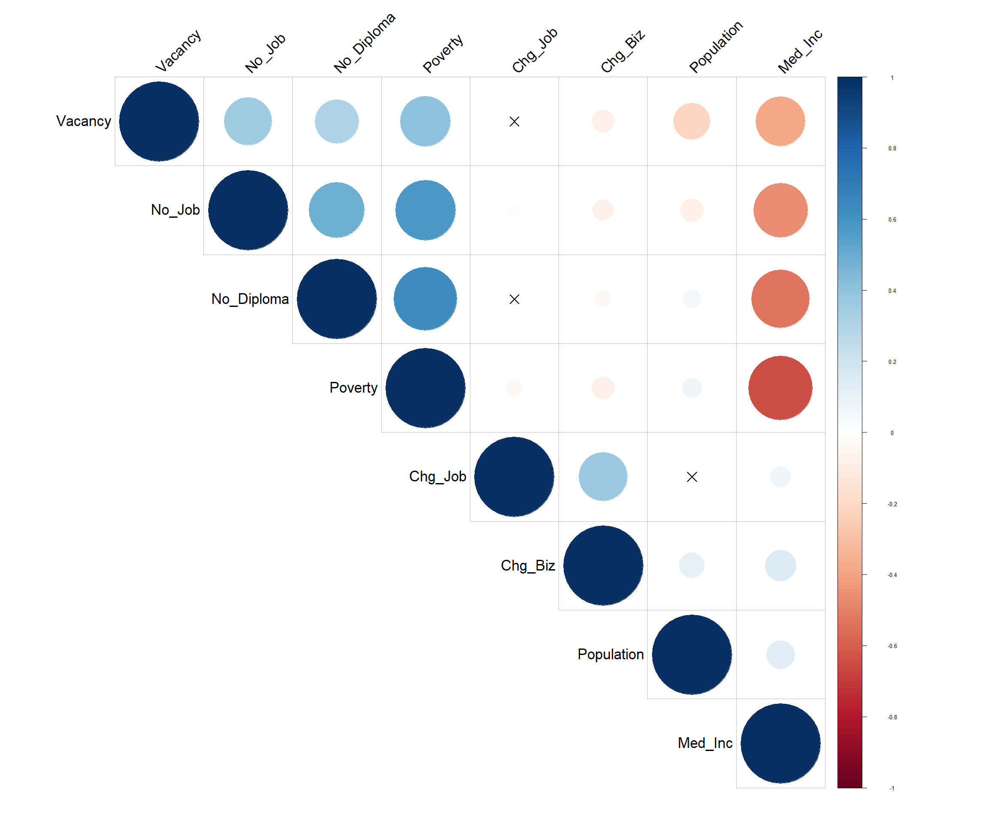

#Visualization /w scatterplots  
library(PerformanceAnalytics)

## Warning: package 'PerformanceAnalytics' was built under R version 3.4.4

## Loading required package: xts

## Warning: package 'xts' was built under R version 3.4.1

## Loading required package: zoo

## Warning: package 'zoo' was built under R version 3.4.1

##   
## Attaching package: 'zoo'

## The following objects are masked from 'package:base':  
##   
## as.Date, as.Date.numeric

##   
## Attaching package: 'PerformanceAnalytics'

## The following object is masked from 'package:graphics':  
##   
## legend

chart.Correlation(DCI_3, historgram=TRUE, method="pearson", pch=19)

